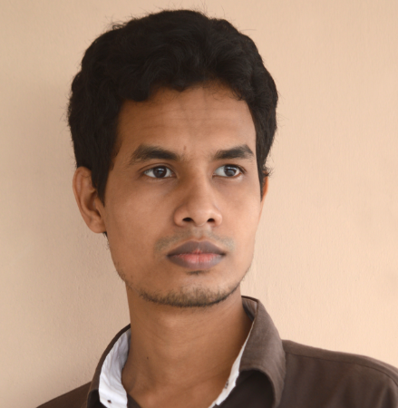
Resume

Zulkar Nine
93/A Kolabagan Dhaka
Phone : +8801989419776
E-mail : zulkarnine43@gmail.com

► Career & application information

To pursue a challenging job in a dynamic and esteemed organization where there is an environment of proving my worth, instincts and efficiency and where I can apply my knowledge and sensitivity. I am confident that, I am very much able to work in this field.

► Academic qualification

Course Name : Secondary School Certificate
Institute : Sultanshadi High School and College
Group : Science
Board : Dhaka
Year of pass : 2014
Result :

► Academic qualification

Course Name : Higher Secondary Certificate
Institute : Govt.Safar Ali College
Board : Dhaka
Group : Science
Year of passing : 2016
Result Achieved :

► Personal information

Name : Zulkar Nine
Father’s Name : Md.Abdur Rahman
Mother’s Name : Asma Akter
Present Address : 93/A Kolabagan, Dhaka
Permanent Address : Araihazar, Narayangonj

Date of Birth : 25/09/1997
Marital status : Singel
Sex : Male
Blood Group : AB+
Religion : Islam
Nationality : Bangadeshi
E-mail : zulkarnine43@gmail.com
Contact No. : +8801989419776

►Computer Skills

- Graphics Design, Web develope , Office Management, Computer Hardware & Networking.

► Work Experience

- Work as It Expert at Graphic & Web Design.

► Language Proficiency

- Excellent proficiency in Bangla – listening, reading, writing and speaking.
- English- listening, reading and writing.

► Reference

- Dr.Helal

► Personal Statement

I, the undersigned, certify that to the best of my knowledge and belief, these curriculum vitae correctly describe me, my qualifications and experiences

Zulkar Nine Date: 15/03/2019

